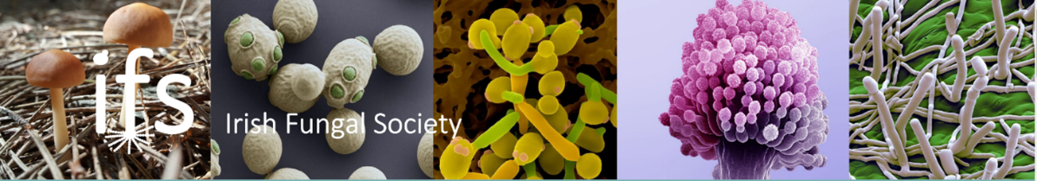
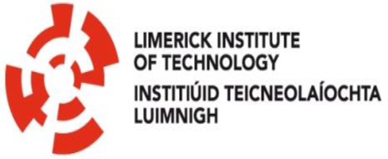

ANNUAL IRISH FUNGAL SOCIETY MEETING
LIMERICK INSTITUTE OF TECHNOLOGY
June 15th & 16th 2017

PROUDLY SPONSORED BY:
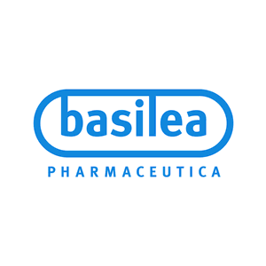

Lectures in Room 4A02. Tea/Coffee and posters/ exhibitions in Aula Max
- June 15th

Day 1 | 15th June 2017
9.25-9.30 | Welcome address | Liam Browne, Vice President Research, Enterprise & Development, Limerick Institute of Technology
Chair: Catherine Collins
Session 1 Industrial Biotechnology/microbiology
9.30-10.00 | Dr. Andy Bailey  University of Bristol | Manipulation of Fungal Gene Clusters to produce Pharmaceuticals and Agrochemicals  Sponsored by Microbiology Society
10.00-10.30 | Dr. Marilyn G. Wiebe, VTT Technical Research Centre of Finland, Finland  Sponsored by  Microbiology Society | Improving Production of Mucic Acid, an Organic Diacid, with Fungi  Sponsored by Microbiology Society
10.30-10.45 | Dr. Mary Heneghan,  Institute of Technology Sligo | Establishing Polyketide Biosynthetic Pathways in Beauveria bassiana
10:45-11:00 | Raúl A. Ortiz-Merino,  University College Dublin | Zygosaccharomyces parabailii: a hybrid species which regained fertility after whole-genome duplication
11.00-11.30 Tea/Coffee
Chair: Tim Yeomans
11.30-12.00 | Dr. Andre Canelas, Kerry Foods | Fungal enzymes in action: Kerry Enzymes celebrating 50 years of enzymes expertise
12.00-12.15 | Ronan O’Donnell,  Institute of Technology Sligo | Development of an efficient Rasamsonia emersonii ‘Molecular toolkit’ and transformation system
12.15-12.30 | Dr. Sinéad Phelan,  Teagasc | Does the introduction of resistant potato lines or the application of fungicides effect local populations of Phytophthora infestans?
12.30-13.30 Lunch
Chair: Gary Moran
Session 2 Antifungal Agents
13.30-14.00 | Prof Ted White  University of Missouri-Kansas City | Analysis of azole resistance mechanisms using overexpression in Saccharomyces cerevisiae
14.00-14.30 | Dr. Jerry Reen, University College Cork | A Systems Approach to Mining Cellular Communication Networks
14.30-14.45 | Qinxi Ma,  University College Dublin | Mechanism of action of medium chain fatty acids as antifungal agents against Candida albicans and Candida parapsilosis
14.45-15.00 | Siobhán A. Turner,  University College Dublin | Identification of novel repressors of adhesion in Candida parapsilosis
15.00-15.15 Tea/Coffee
Chair: Tom Rogers
Session 3 Case Studies Session
15.15-15.45 | Dr. Nuala O’Connell, University Hospital Limerick | A romp through emerging issues in clinical mycology
15.45-15.55 | Case study 1  Grace Chan, University Hospital Waterford | Cryptococcal Conundrum
15.55-16.05 | Case study 2  Dr. Julie Mac Mahon  Mater University Hospital, Dublin | Aggressive cutaneous dermatophyte infection in a cardiac transplant patient
16.05-16.15 | Case study 3  Ruth Waldron,  St. James Hospital, Dublin | Candida krusei pericarditis in an immunosuppressed patient: A case report
16.15-16.25 | Case study 4  Aia Mohamed,  St. James Hospital, Dublin | An unusual case of mucormycosis post lobectomy
16.25-16.35 | Case study 5  Dr. Donnchadh O’Sullivan,  University Hospital Limerick | A Rare Case of Bilateral Upper Lobe Aspergillomas in a Paediatric Patient with Cystic Fibrosis
Session 4 Posters
16.35-18.00 Poster Session
19.30 Conference Dinner. Strand Hotel.

- June 16th

Day 2 | 16th June 2017
Chair: Ted White
Session 1 Fungal Pathogens
9.30-10.00 | Dr Jorge Amich, Manchester Fungal Infection Group (MFIG), University of Manchester | Sulphur metabolism in Aspergillus fumigatus infection: in search of new antifungal treatments.  Sponsored by Microbiology Society
10.00-10.15 | Dr. Julie Renwick,  Trinity College Dublin | Aspergillus fumigatus and Pseudomonas aeruginosa Co-Colonisation in Cystic Fibrosis
10.15-10.30 | Gerard Sheehan, Maynooth University | The human cathelicidin antimicrobial peptide LL-37 augments the growth of the pulmonary pathogen Aspergillus fumigatus
10.30-10.45 | Dr. Katie Dunne,  Trinity College Dublin | A prospective screen of clinical and environmental isolates of Aspergillus fumigatus for triazole resistance
10.45-11.00 | Peter Flanagan,  Trinity College Dublin | Heterologously expressed Candida albicans TLO genes exhibit variable phenotypes
11.00-11.30 Tea/Coffee
Chair: Andy Bailey
11.30-12.00 | Dr. Helen Grogan, Teagasc | Multiple viral infections in the commercial mushroom Agaricus bisporus - characterisation and epidemiology  Sponsored by Roche
12.00-12.30 | Dr. Magdalena Martin-Uridoz, University of Exeter | Investigating membrane curvature generation and quinate utilisation during plant infection by Magnaporthe oryzae  Sponsored by Roche
12.30-12:45 | Charley McCarthy,  Maynooth University | Horizontal gene transfer analysis and phylogenomic reconstruction of the oomycetes
12:45-13:00 | Jamie McGowan,  Maynooth University | Genomic, Network and Phylogenetic Analysis of the Oomycete Effector Arsenal
13.00-13.30 Irish Fungal Society AGM
Packed Lunch

