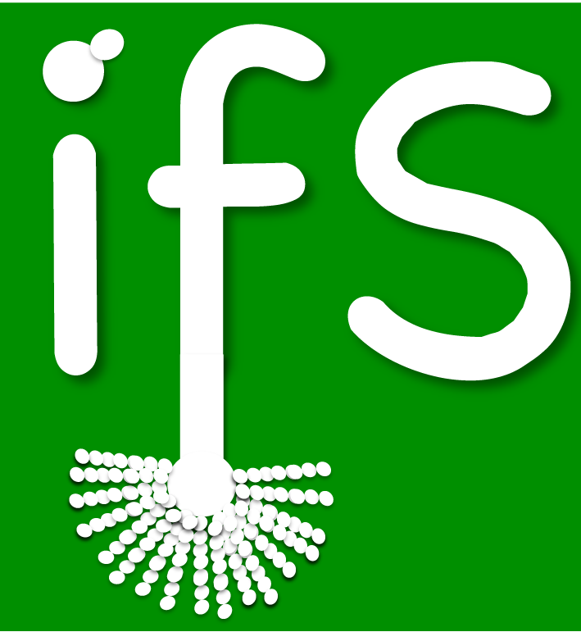

Call for Offered Papers
IFS Annual Scientific Meeting
March 20th – 22nd 2016
Grand Hotel, Malahide, Co. Dublin

ABSTRACT Submission Form

We are pleased to announce the call for offered papers for the 2016 IFS Annual Scientific meeting in Malahide, Co. Dublin. We invite submissions on any aspect of research in the field of fungal biology and mycology. The organising committee will review submitted abstracts.

Please indicate your preferred method of presentation: ORAL / POSTER / DON’T MIND

Please indicate if presenting author is a PI or postdoc: YES / NO

Please indicate if presenting author is a PhD student or trainee: YES / NO

Please indicate if you would like to be considered for a PhD student/trainee prize talk: YES / NO

Please indicate if you would like to be considered to present in the “Poster Talk” session: YES / NO

- Please submit your abstract using the template at the end of this document.
- The deadline for submissions is 01/02/16.
- Authors will receive confirmation of acceptance and will be informed of whether their abstract has been selected for poster or oral presentation by 12/02/16

Submit your abstract by email to: irishfungalsoc@gmail.com

Abstract Template:

Paper Title (Arial, bold, 14pt)

First name, surname¹, …... , & First name, surname ^{X} (Arial, 12pt. Presenting Author is to be underlined)

^{x}Department/Faculty of..., University of ... , Address…, Country, e-mail: ... (Arial, italic, 11pt)

The text of the abstract is to be placed here. The abstract should be concise and should present the aim of the work, essential results and conclusion. It should be typed in Arial 11pt, single-spaced.

THE ABSTRACT LENGTH SHOULD
NOT EXCEED 300 WORDS

